Special Screening of Toilet: Ek Prem Katha

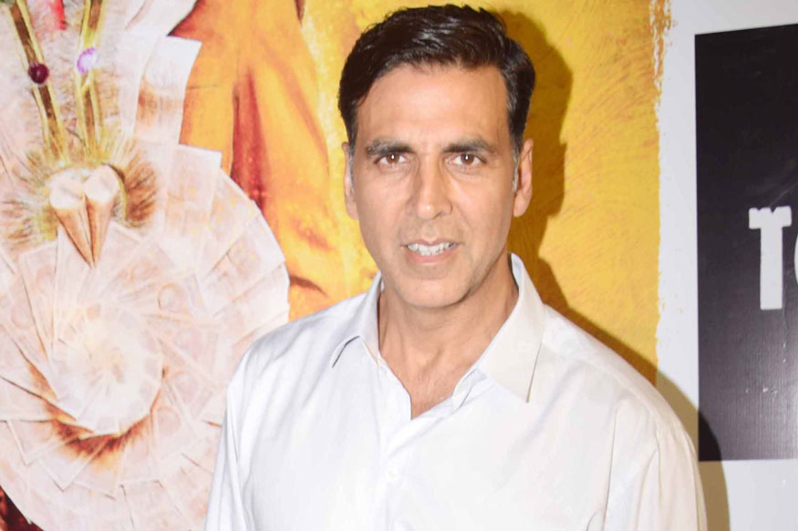Toilet: Ek Prem Katha's special screening was organised by its makers before its release. Many b.town celebrities have shown their presence in the screening. They liked the Akshay's patriotism and also tweeted appreciation for the film. Starring Bhumi Pednekar and Akshay Kumar, Toilet Ek Prem Katha is directed by debutant Shree Narayan Singh. The film is based on Modi's Clean India campaign. It will be highlighting the disadvantages of open defecation through a humorous tale.

From Kriti Sanon to Madhuri Dixit, John Abraham to Sara Ali Khan, many stars were there. Let’s have a look.

